**LAMPIRAN C**

**KETERANGAN TABEL 4**

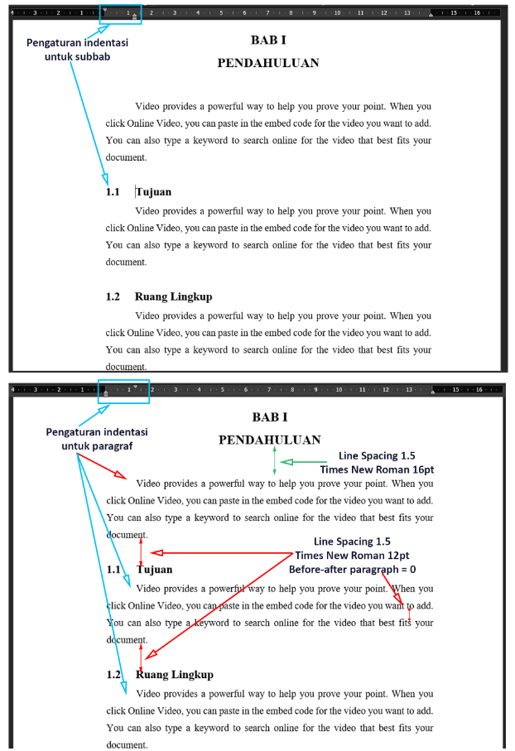

**Gambar C.1**

**Pengaturan Indentasi**